Microsoft Cloud for Retail

In A Day

Lab 05: Retail Churn Model

Step-by-Step Lab

March 2022

Contents

Overview 3

Learning Objectives 4

Retail Story 4

Prerequisite(s) 5

Customer Intelligence 5

Exercise 1: Create and Configure Dynamics 365 Customer Insights Environment 5

Task 1: Create Customer Insights Environment 6

Task 2: Deploy Retail Churn Model 10

Exercise 2: Configure Retail Churn Model in Dynamics 365 Customer Insights 13

Task 1: Add a Data Source 13

Task 2: Unify Your Data 26

Task 3: Train the model 33

Exercise 3: Understand the Churn Model Output 40

Summary 45

Overview

Unified customer profile is one of the key capabilities of Microsoft Cloud for Retail. In some ways, it’s where the data story comes together. So, what does it do? Unified customer profile helps you gain insights across the complete view of a shopper’s journey.

With unified customer profile, you can gain a 360-degree perspective of the customer in a clear and intuitive way so that you can provide personalized experiences, reveal important opportunities, prevent potential loss, or churn, and improve customer satisfaction.

Unified customer profile bolsters **unification**. You can:

* Bring multiple identities together to create a 360 view of the customer through AI-powered identity resolution
* Ingest multiple types of data, behaviors, and customer sentiment in real time via more than 500+ built-in connectors

It also fosters **unique enrichment**:

* Gain a 360 view of the customer with proprietary audience intelligence from Microsoft Graph
* Leverage cross-channel behavior to complete the picture of your end-customer

Furthermore, Unified customer profile also gives you better access to customer **insights**:

* Gain more nuanced insights by combining digital analytics with customer profiles to create richer segments, and leverage churn models to understand churn risk at a glance
* Observe customer progress through each defined step of the journey, quickly identifying obstacles and opportunities
* Create custom reports and views based on real-time customer behavior data, leverage built-in web and mobile analytics to predict customer needs

Learning Objectives

Retail Story

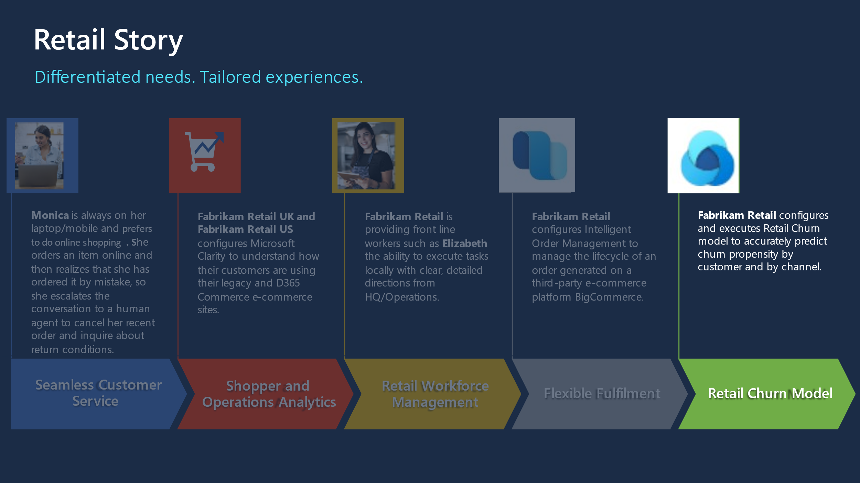

This lab will focus on the retail story of Fabrikam Retail.

In the following exercises, you will be playing the role of a System Administrator and a Developer:

In **Exercise 1**, you will be creating a **Customer Insights** environment and deploy **Unified customer profile** via Solution Center. In **Exercise 2**, you will learn the steps to import Fabrikam retail’s customer data from azure blob storage, generate retail churn model and analyze the churn predictions.

Prerequisite(s)

* Dynamics 365 Customer Insights

Customer Intelligence

Customer intelligence unifies important, relevant, and accurate customer information across multiple sources via Dynamics 365 Customer Insights. This solution empowers the agent to engage with customers based on relevant insights. Customer intelligence combines demographic information, financial measures, and attitudes to form financial segments and AI models. These insights help agents to quickly understand the customer.

Prerequisites:

* At least Contributor permissions in Dynamics 365 Customer Insights. More information: [User permissions](https://review.docs.microsoft.com/en-us/dynamics365/customer-insights/audience-insights/permissions).

Exercise 1: Create and Configure Dynamics 365 Customer Insights Environment

***Note****: If you have already deployed D365 Customer Insights environment and Unified Customer Profile solution then you can skip this exercise.*

In this exercise, you will create and configure a Dynamics 365 Customer Insights environment in order to deploy the Retail Churn Model.

[Dynamics 365 Customer Insights](https://dynamics.microsoft.com/ai/customer-insights/) is a part of Microsoft's customer data platform (CDP) that helps deliver personalized customer experiences. The platform's capabilities provide insights into who your customers are and how they engage with your platform. Unify customer data across multiple sources to get a single view of customers.

* [Audience insights](https://docs.microsoft.com/en-us/dynamics365/customer-insights/audience-insights/overview) helps you transform your business into a customer-centric organization. Marketing, sales, and service professionals have the insights they need to personalize experiences. Connect data from transactional, behavioral, and observational sources to create a 360-degree customer view. See results faster with a CDP designed to deliver insights that can be acted upon.
* [Retail channel churn predictive model:](https://docs.microsoft.com/en-us/dynamics365/industry/retail/retail-use-churn-prediction) Retail channel churn predictive model, a key feature of Unified customer profile, uses an AI-based model to help omnichannel retailers use cross-channel data to assess the chance that a customer will churn—stop actively buying.

Task 1: Create Customer Insights Environment

In this task you will create a new Customer Insights sandbox environment. To set **Customer intelligence** up correctly, you must first create a Customer Insights sandbox environment and connect it to your Dataverse environment with no Data Sources specified. Once connected, you will go through [Solution Center](https://solutions.microsoft.com) and deploy **Customer intelligence** from **Unified customer profile**, specifying the Customer Insights environment that you create in this task.

1. Using an In-Private or Incognito window, navigate to <https://home.ci.ai.dynamics.com/> and log in with the credentials provided by your instructor.
2. If not already selected, select **Audience insights** as your focus.

1. Your screen would look like this with Audience Insights selected:

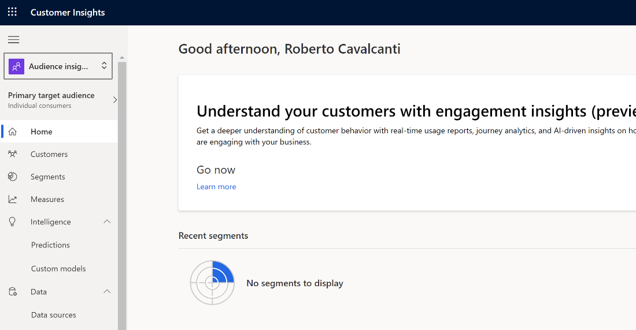

1. In the top right corner of the screen, click on the environment name and then click **+ New** to create a new environment

1. Fill out the appropriate fields and click **Next**.
   1. **Name**: <<UserName>> Retail Churn
   2. **Choose your business**: Individual consumers (B-to-C)
   3. **Type**: Pitch Demo
   4. **Region**: West US

1. **Deselect** Power BI Reporting and click **Next**.

1. Leave **Customer Insights storage** selected and click **Next**.

1. Leave the Microsoft Dataverse environment URL blank and click **Next**.

1. Click **Create**.

1. Wait for the environment to be created

**Congratulations!** You have successfully created a CI environment.

Task 2: Deploy Retail Churn Model

* 1. Open a **new tab** in our internet browser and navigate to the Microsoft Cloud Solution Center at [solutions.microsoft.com](https://solutions.microsoft.com)
  2. Expand **Retail** and navigate to **Unified customer profile**. Check **Add** next to Unified customer profile and then click **Deploy**.

1. Select the **Customer Insights Environment** that you created in the previous task, **provide a name** for your deployment, **agree** to the terms and conditions, and click **Next**.

1. Click Deploy to deploy the Retail Churn model to your Customer Insights environment.

1. Deployment will take several minutes to complete.

1. Once the deployment has completed, click **Close**.

**Congratulations!** You have successfully deployed Retail Churn Model.

Exercise 2: Configure Retail Churn Model in Dynamics 365 Customer Insights

In this exercise, you will configure the Retail Churn Model in the Dynamics 365 Customer Insights environment you created in the previous exercise.

Task 1: Add a Data Source

In this task, you will add a data source for your Retail Churn model.

* 1. Navigate to your newly created Customer Insights environment, expand **Data,** and go to **Data sources**. Click **Add data source**.

* 1. Select **Microsoft Power Query** save the data source as “RetailGroceryChurn”, and then click **Next**.

* 1. Choose the **Azure Blobs** connector.

* 1. Refer to the **Storage Account name** and **Access Key** provided in your lab assignment document for this step.

1. Select **retailgrocery** and click **Transform data**.

1. Click the **[Binary]** link in the first cell of the first row for the **Grocery_contact.csv** file.

1. Go to the **Transform** ribbon and then select the **Use first row as headers** option

1. Right click the **birthdate** column, go to **Change type**, and select **Date**.

1. Select the following columns by holding down the **Ctrl key** on your keyboard: annualincome, msrc_creditscore, msrc_customerrelationshipduration, and msrc_distancetoneareststore. Once highlighted, right click one of them, go to **Change type**, and select **Decimal number**.

1. Finally, under Properties on the right side, change the **Name** to “contact” and hit the **Enter** key on your keyboard. DO NOT CLICK SAVE.

1. Right-click the contact query and select Duplicate.

1. Right-click the duplicated query and rename it to “transactions”.

1. With the **transactions** query selected, delete all the **Applied steps** on the right up to the Navigation step.

1. Click the **[Binary]** link in the first cell of the third row for the **Grocery_msrc_transaction.crv** file.

1. As before, go to **Transform** and select **Use first row as headers**.

1. Scroll over to and select the **msrc_transactiontimestamp** column. Right-click and **Change type** to **Date/Time**.

1. Press and hold the **Ctrl key** on your keyboard to select both the **msrc_transactionamount** and **msrc_discountappliedamount** columns. Right-click one of the columns, go to **Change type**, and select **Decimal number**.

1. Right-click the **transactions query** and select **duplicate**.

1. Rename the query to “**session**” and delete all the **Applied steps** up to Navigation like you did before.

1. Click the **[Binary]** link in the first cell of the second row for the **Grocery_msrc_session.csv** file.

1. Go to **Transform** and select **Use first row as headers**.

1. Right-click **msrc_sessiontimestamp**, go to **Change type** and select **Date/Time**.

1. Right-click the **msrc_sessionduration** column, go to **Change type**, and select **Decimal number**.

1. Finally, right-click the **msrc_sessioncustomersatisfaction** column, go to **Change type**, and select **Whole number**.

1. Click **Save** and monitor the Data source as it refreshes. This step should take a few minutes.

Task 2: Unify Your Data

1. In Customer Insights, go to **Unify**.

1. Select all **three** entities and click **Apply**.
2. Select the **contact** entity, then select **contactid** as the primary key.

1. Select the **session** entity, then select **msrc_sessionid** as the primary key.
2. Select the **transactions** entity, then select **msrc_transactionid** as the primary key.
3. While still under Unify, click **Match**, and then click **+ Set order**.
4. In the pop-out, click + Add at the bottom to add a third entity.

1. Select the entities in the following order: **contact**, **transactions**, **session**. Ensure **Include all** is checked for all entities and click **Done**.

1. Click **+ Add rule** next to the **transactions** entity.

1. Select **contactid** and **msrc_customerid**, then name the rule “contacttransactions”. Click **Done**.

1. Scroll down and click + Add rule next to the session entity.

1. Choose the **transactions** entity and then select the **msrc_transactionsessionid** and **msrc_sessionid** fields. Name the rule “transactionssession” and click **Done**.

1. Click **Save**.

1. Click **Run**. This step will take several minutes to complete. Once it is done, we will then merge the data.

1. Under **Unify**, click **Merge** and then click **Save**.

1. Once saved, click **Run** and select **Run only Merge**. This will take several minutes to complete.

**Congratulations!** The model should be visible and ready to train, follow the next steps to train the model.

Task 3: Train the model

1. Navigate to **Predictions** on the left menu, select Create and then click the **Retail channel churn (preview)** **Use model** button.

1. When the pane pops out, click the **Get started** button.

1. Name the model and output entity “RetailChurnModel”.

1. Adjust the Model preferences as needed and click **Next**.

1. Click on the **+ Add data** button below the Customer session on the middle pane. It will open a right pane to let you add the required customer data from the customer entity. Click **Save** when done to return to the middle pane.

1. Repeat the process with the Transaction data by clicking the second **+ Add data** button below the Transaction section on the middle pane. Fill out the transaction entity information on the right pane and lick on **Save**. Click **Next** on the middle pane.

1. Once both required data entities are complete, click **Next** to go to Additional data.

1. Click **+ Add data** to enter the Session information, **save** it and click **Next**.

1. Set the data update schedule as **Weekly** and click **Next**.

1. Confirm everything looks correct and click **Save and Run**.

1. Confirm that the model is running and click on **Done.**

1. Monitor the status of the request to see when it is finished. There is a chance you may receive an error on the first run. If you receive an error, simply run the prediction model again and it typically works on the second try.

1. It is possible you may receive an error on the first run, simply click Refresh all to run the model again.

**Congratulations!** You have run the Retail channel churn predictive model.

Exercise 3: Understand the Churn Model Output

In this exercise, you will review the output of the Retail Churn model.

* 1. Open the Retail churn model to view its contents. Here you will find three main areas:
     1. **Training model performance** will display a letter grade of how well the model has performed.
     2. **Likelihood to churn (number of customers)** that can be read as X customers are Y% likely to churn.
     3. **Most influential factors** considered by the AI in predicting the model. This will vary depending on the data set.

* 1. To view a customer’s full profile in Dynamics 365 Customer Insights, navigate to Customers and open any of the sample records.

* 1. To view the calculated churn scores, navigate to **Data** and then under **Entities**, open the RetailChurnGrocery entity that was created when you ran the churn model

* 1. On the Attributes tab, you will find various new columns created by the model that factor into the score. Here is a breakdown of some of these attributes:
     1. ExpFeature1 = Contact related factors
     2. ExpFeature2 = Digital transaction factors
     3. ExpFeature3 = Physical transaction factors
     4. ExpFeature4 = Digital session factors
     5. ExpFeature5 = Physical session factors

* 1. Click the **Data** tab to see the calculated churn score for each of the **CustomerIDs** in the dataset.

**Congratulations!** You have successfully run the Retail Churn Model in Dynamics 365 Customer Insights.

Summary

**Nice work!** You have completed the lab for Microsoft Coud for Retail channel churn predictive model.

In this lab, you learned how to do the following:

1. Create Retail channel churn predictive model
2. Train the model
3. Understand the model output